- the time slot reflected for walkin patients is wrong – whereas it is correct for scheduled patients
- There should also be an option to view/download prescription of a patient for any of the visits made till date.
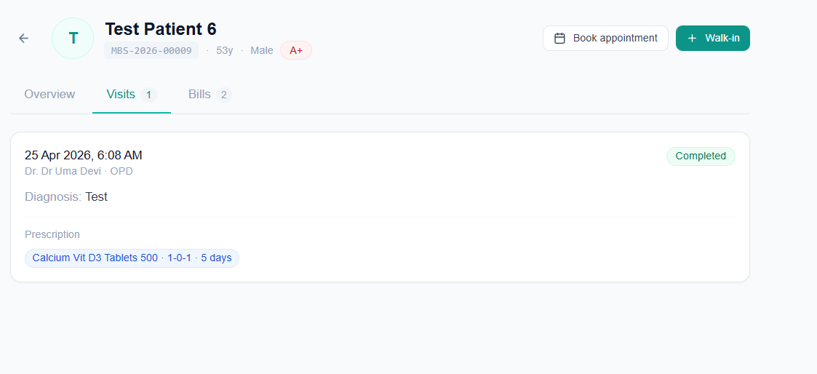
- The billing is getting added twice for a patient. For example today – I have registered only 1 patient walk-in appointment with fee Rs. 700 and marked as payment received. But after OPD consultation form was filled for that patient – the billing section now shows Rs. 1400 billed with Rs. 700 payment due (as you can see on the screenshot in “Patient’s Page” – there we can see – “visits 1” but “Bills 2”
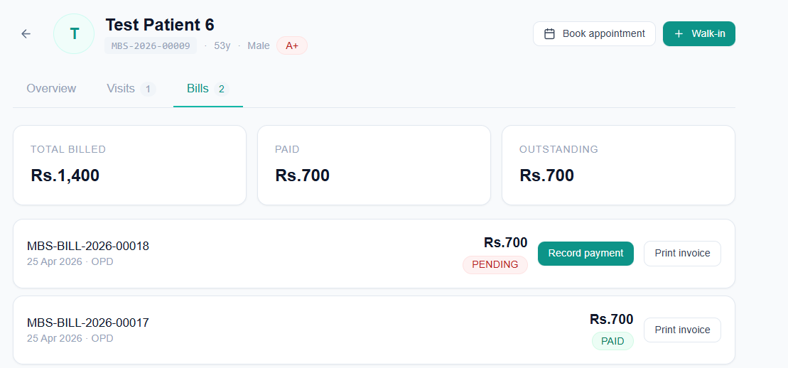
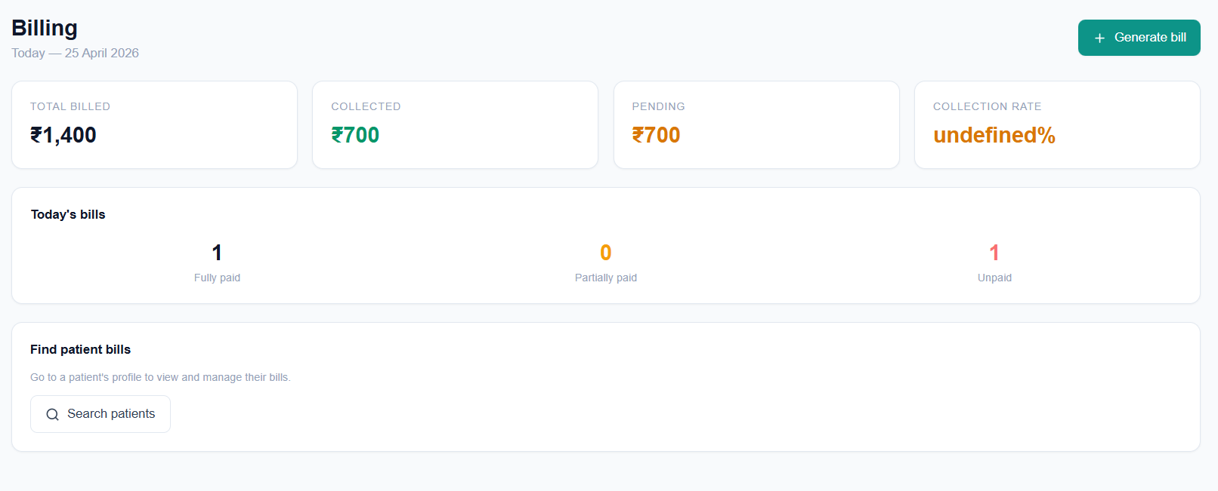
- The collection rate in billing page is still “Undefined %”
- After clicking on the “visits” box in the dashboard – it redirects me to “OPD” page – but ideally it should redirect me to Appointments page
- After I select a patient profile from the patient page and click on Walk-in/Book Appointment from that patient’s profile – the walk-in/Book appointment page is not prefilled with the patient name. This pre-fill should only be there when user tries to book an appointment/register walk-in directly from a patient’s profile

